Prática 10 - PL/SQL- PACKAGE
Data da Entrega: 21-11-2016

1. Dadas as PROCEDURES ADD_JOB, UPD_JOB e DEL_JOB e a FUNCTION Q_JOB, crie a especificação da PACKAGE JOB_PACK e seu respectivo corpo (BODY). Em seguida teste cada um dos procedures e a função.

Crie a tabela JOBS com o seguinte comando:

CREATE TABLE jobs AS SELECT empno, job FROM emp;

Procedure ADD_JOBS

PROCEDURE add_job
(p_jobid IN jobs.empno%TYPE,
p_jobtitle IN jobs.job%TYPE)
IS
BEGIN
INSERT INTO jobs (empno, job)
VALUES (p_jobid, p_jobtitle);
END add_job;

Procedure UPD_JOBS

PROCEDURE upd_job
(p_jobid IN jobs.empno%TYPE,
p_jobtitle IN jobs.job%TYPE)
IS
BEGIN
UPDATE jobs
SET job = p_jobtitle
WHERE empno = p_jobid;
IF SQL%NOTFOUND THEN
RAISE_APPLICATION_ERROR(-20202,’No job updated.’);
END IF;
END upd_job;

Procedure UPD_JOBS

PROCEDURE del_job
(p_jobid IN jobs.empno%TYPE)
IS
BEGIN
DELETE FROM jobs
WHERE empno = p_jobid;
IF SQL%NOTFOUND THEN
RAISE_APPLICATION_ERROR (-20203,’No job deleted.’);
END IF;
END del_job;

Função Q_JOB

FUNCTION q_job
(p_jobid IN jobs.empno%TYPE)
RETURN VARCHAR2
IS
v_jobtitle jobs.job%TYPE;
BEGIN
SELECT job
INTO v_jobtitle
FROM jobs
WHERE empno = p_jobid;
RETURN (v_jobtitle);
END q_job;

Package JOB_PACK
CREATE OR REPLACE PACKAGE JOB_PACK
IS

PROCEDURE add_job (p_jobid IN jobs.empno%TYPE, p_jobtitle IN jobs.job%TYPE);
PROCEDURE upd_job (p_jobid IN jobs.empno%TYPE, p_jobtitle IN jobs.job%TYPE);
PROCEDURE del_job (p_jobid IN jobs.empno%TYPE);
FUNCTION q_job (p_jobid IN jobs.empno%TYPE) RETURN VARCHAR2;

END JOB_PACK;

create or replace PACKAGE BODY JOB_PACK
IS

PROCEDURE add_job
(p_jobid IN jobs.empno%TYPE,
p_jobtitle IN jobs.job%TYPE)
IS
BEGIN
INSERT INTO jobs (empno, job)
VALUES (p_jobid, p_jobtitle);
END add_job;

PROCEDURE upd_job
(p_jobid IN jobs.empno%TYPE,
p_jobtitle IN jobs.job%TYPE)

IS
BEGIN
UPDATE jobs
SET job = p_jobtitle
WHERE empno = p_jobid;
IF SQL%NOTFOUND THEN
RAISE_APPLICATION_ERROR(-20202,'No job updated.');
END IF;
END upd_job;

PROCEDURE del_job
(p_jobid IN jobs.empno%TYPE)
IS
BEGIN
DELETE FROM jobs
WHERE empno = p_jobid;
IF SQL%NOTFOUND THEN
RAISE_APPLICATION_ERROR (-20203,'No job deleted.');
END IF;
END del_job;

FUNCTION q_job
(p_jobid IN jobs.empno%TYPE)
RETURN VARCHAR2
IS
v_jobtitle jobs.job%TYPE;
BEGIN
SELECT job
INTO v_jobtitle
FROM jobs
WHERE empno = p_jobid;
RETURN (v_jobtitle);
END q_job;

END JOB_PACK;

Teste da procedure add_job

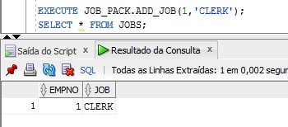

Teste da procedure upd_job

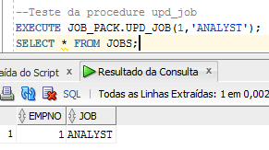

Teste da procedure del_job

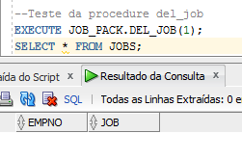

Teste da procedure q_job

